Assignment 1

**Question 1.**

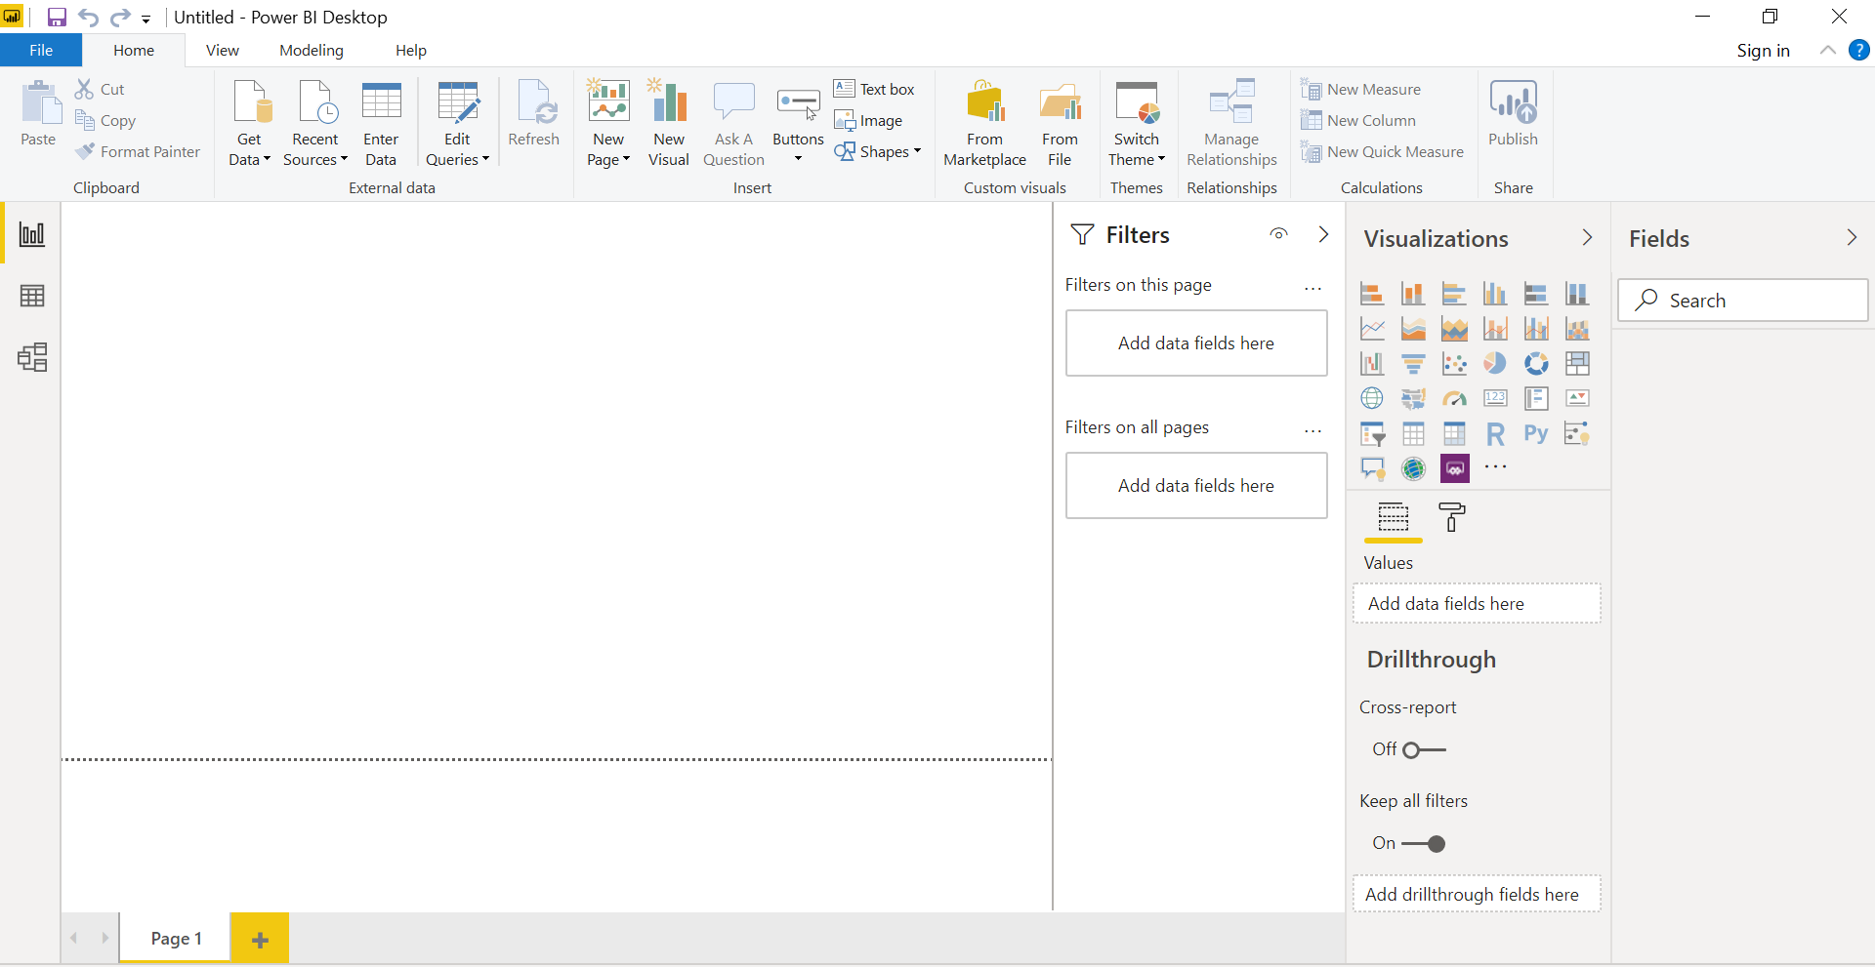

**Question 2:**

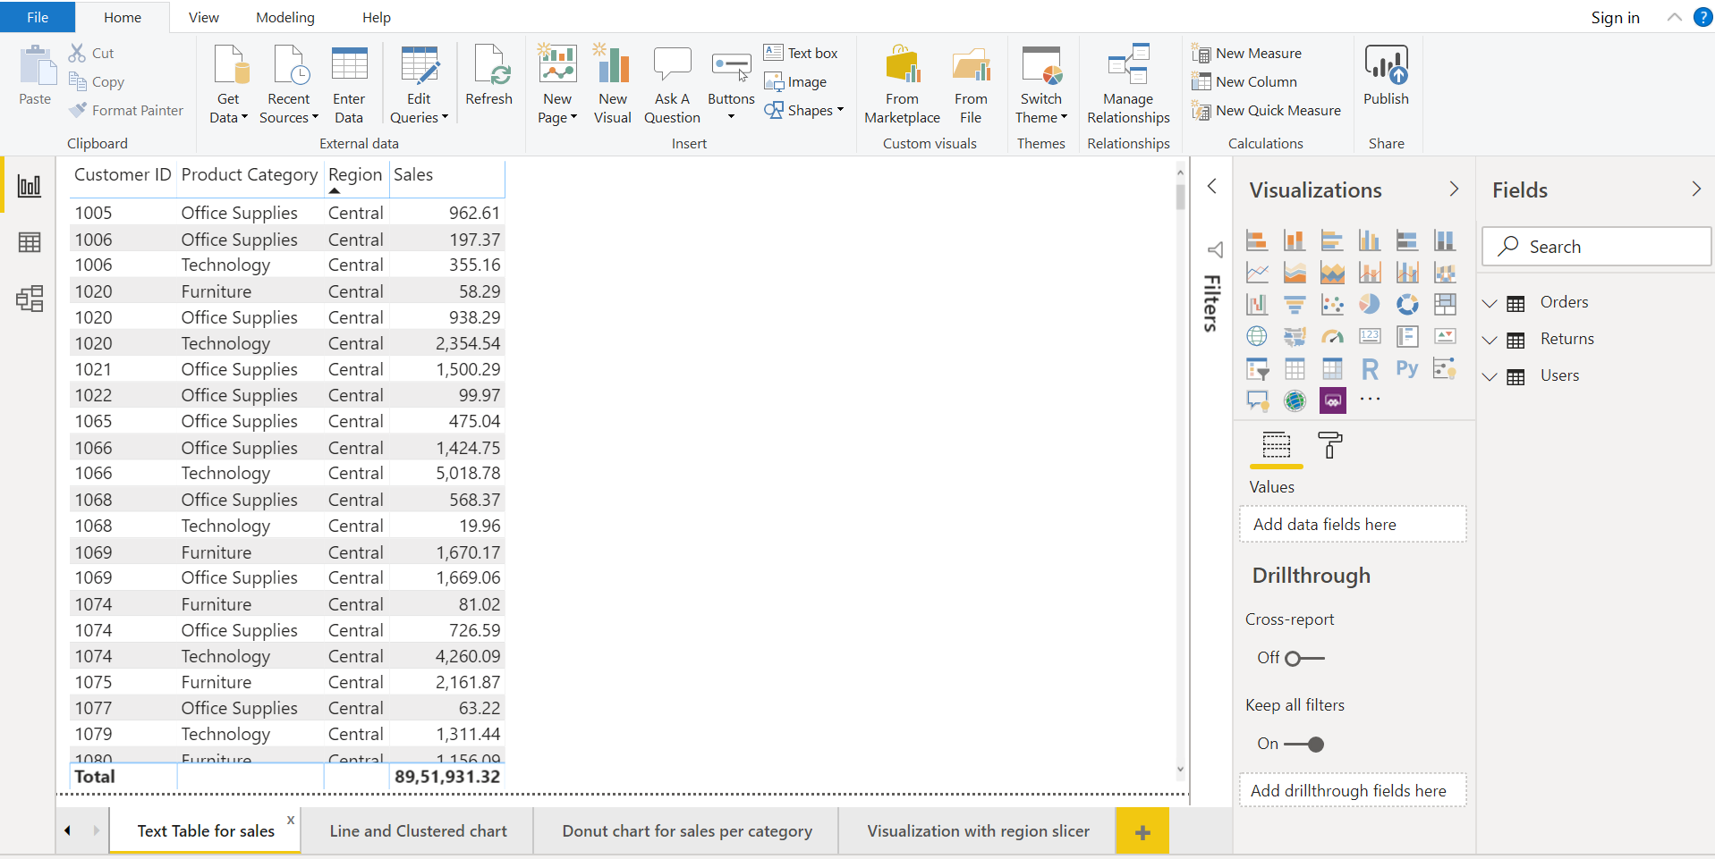

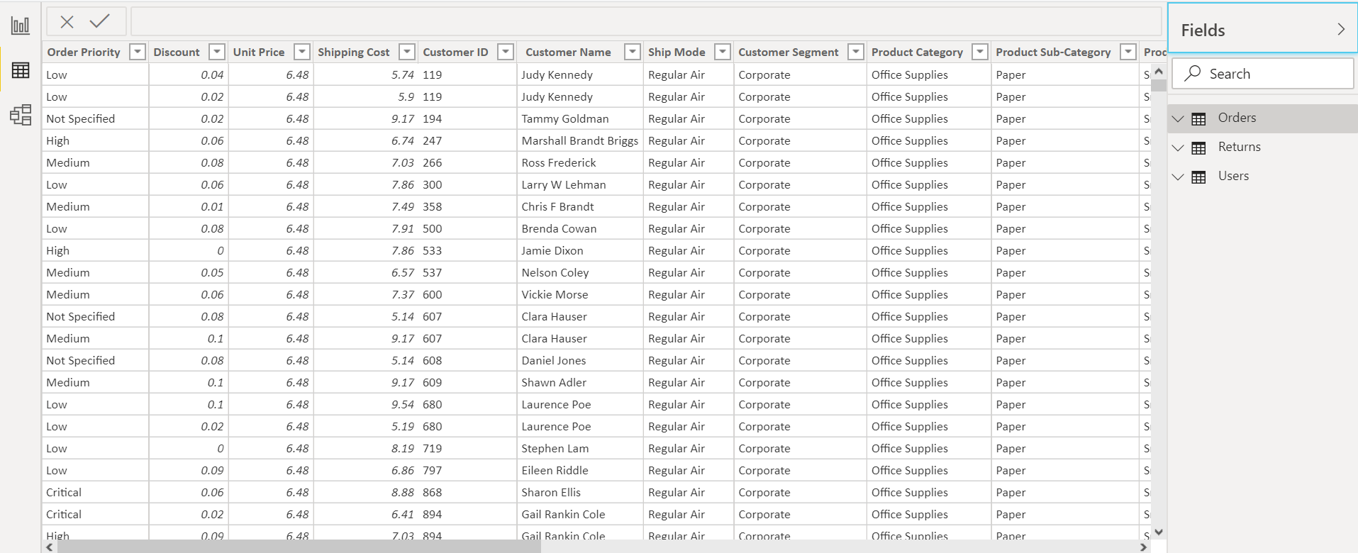

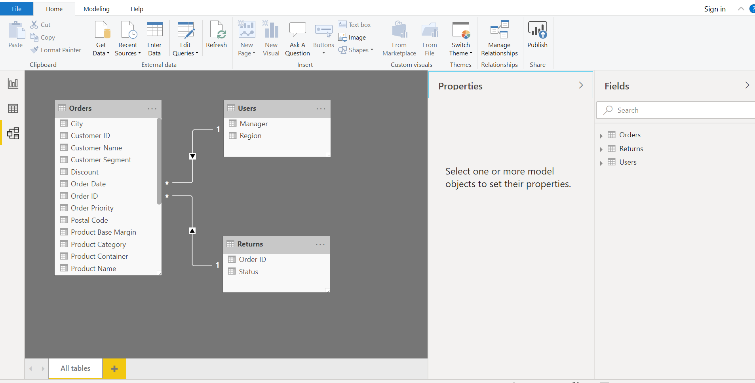

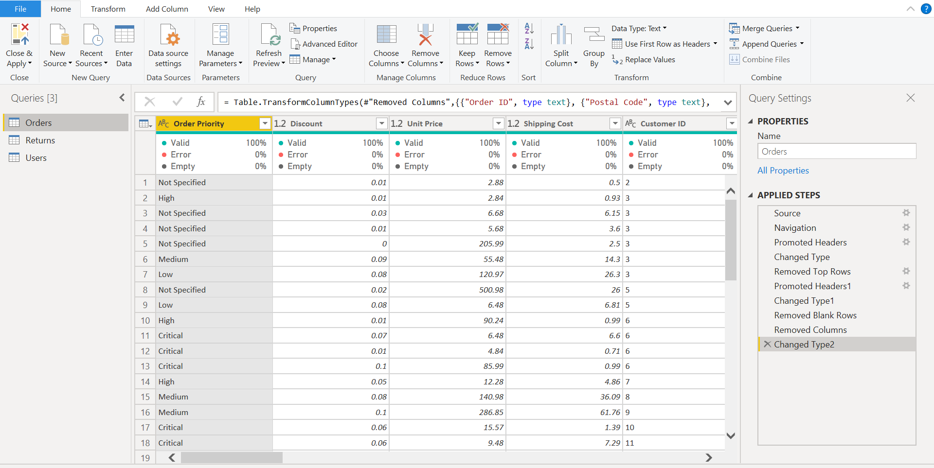

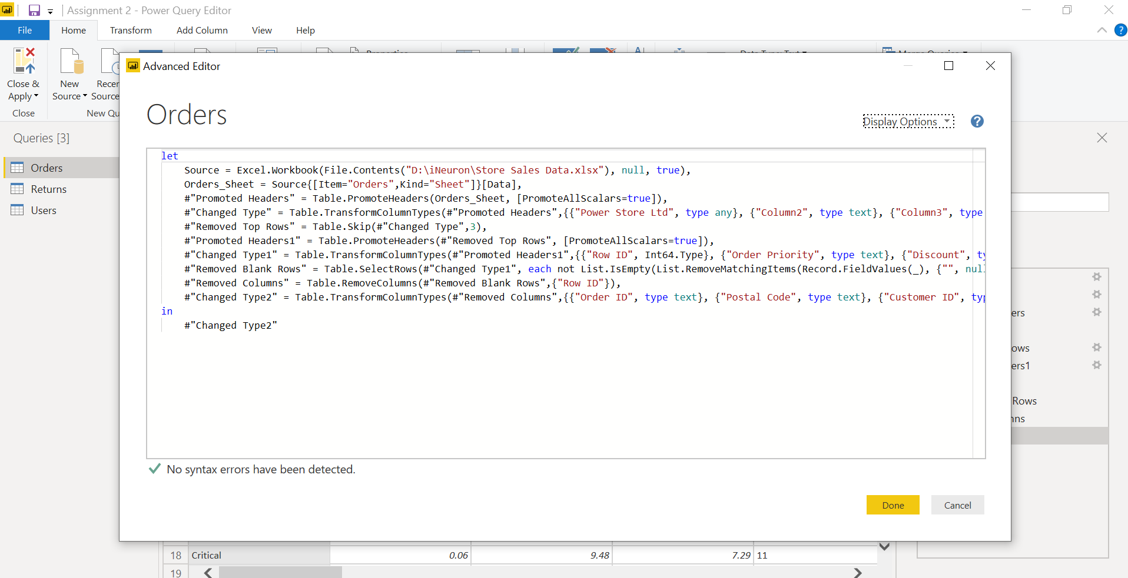

**Question 3.**

|  |  |
| --- | --- |
| **Tool** | **Price** |
| Power BI Desktop | Free for individual users |
| Power BI Pro | $9.99/user/month |
| Power BI Premium | $5,004.99 per month ($9.99 + $4,995) |